To import bookmarks from Chrome, Firefox, IE or any other browser, first export those bookmarks into html file. Then upload the html file here. This will import all your bookmarks into your Bookkmark account.

Following are the procedures to export bookmarks into html files from the various browsers

1. **Internet Explorer**

* Go to Favorites by clicking on star icon.
* Then click on more options on “Add to favorites”
* Select “Import and export…”

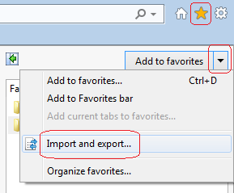

Select “Export to a file” and hit Next and then select “Favorites” and hit Next and the hit Next again until you are prompted for

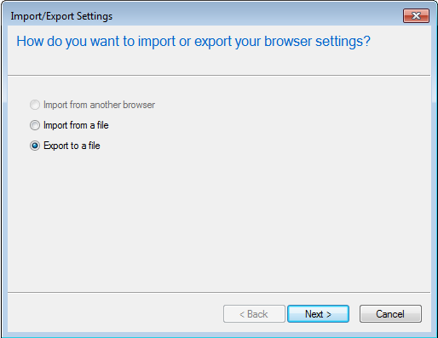

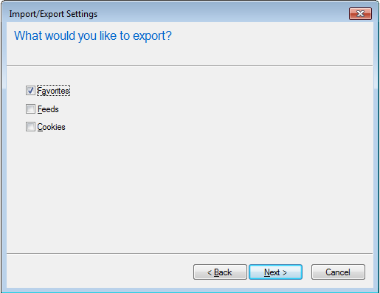

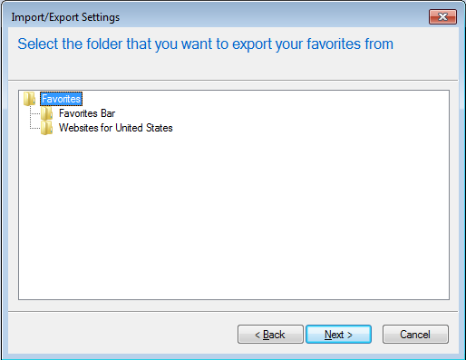

Enter the required name for your file and save it in your device. Upload this same file here to import your bookmarks.

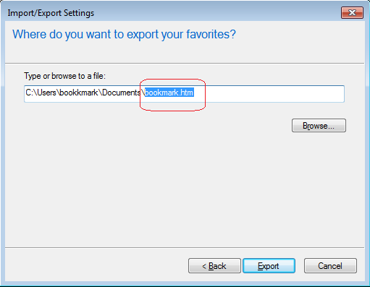

1. **Mozilla Firefox**

Go to “Show your bookmarks” and then select “Show All Bookmarks”, this will open a window

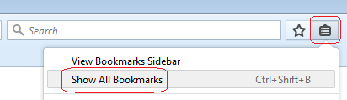

Select “Import and Backup” and then select “Export Bookmarks to HTML”. Then enter the required name for your file and save it in your device. Upload this same file here to import your bookmarks.  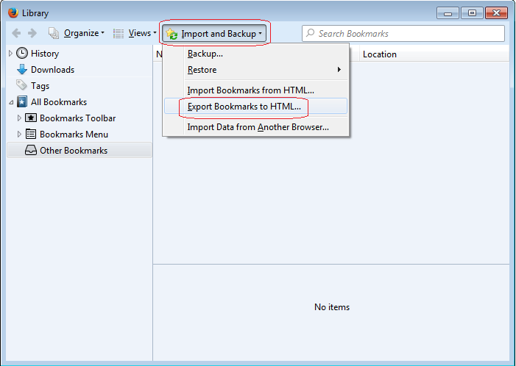

1. **Chrome**